Identifying Distributions – Algebra I/Math I
Below are verbal descriptions of eight different variables. Match these data descriptions to their corresponding histogram, boxplot, and statistics.
A1  Winning scores in NCAA Basketball Tournament  The distribution of winning scores for every NCAA Basketball Tournament game from 1939 to 1995. | A2  Age when Bachelor’s Degree was Awarded  The distribution of reported ages when a Bachelor’s Degree was awarded for a random sample of college graduates
A3  Days in Office  The distribution of days in office for the first 43 United States Presidents. (George Washington through George W. Bush) | A4  Illinois Driver’s License  The distribution of the age at time when a random sample of Illinois residents first received an Illinois driver’s license.
A5  Weights of Euro Coins  The distribution of the weights (in grams) of euro coins collected from a local bank and weighted by Herman Callaert and his team at Hasselt University in Belgium. | A6  Gross Box Office Receipts  The distribution of the total US gross box office receipts for 49 movies in millions of dollars.
A7  Month of Birth of Best Actor/Actress  The distribution of the months of birth for the Oscar recipients for Best Actor and Best Actress for the years 1929 to 2005. (January = 1) | A8  The Number of Passengers on a Southwest Flight  The distribution of total number of boarded passengers from a random sample of Southwest flights featuring the Boeing 737-800.

List your matches in the table below by recording the number for B, C, and D
A  Verbal Description | B  Histogram | C  Boxplot | D  Statistics
A1 Winning scores in NCAA Basketball Tournament

A2 Age when Bachelor’s Degree was Awarded

A3 Days in Office

A4 Illinois Driver’s License

A5 Weights of Euro Coins

A6 Gross Box Office Receipts

A7 Month of Birth of Best Actor/Actress

A8 The Number of Passengers on a Southwest Flight

Identifying Distributions - Histograms
B1  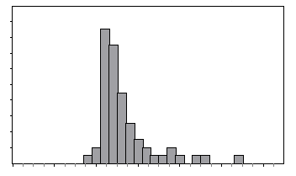 | B2  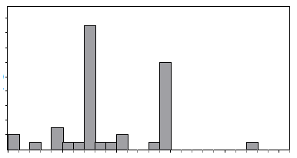
B3  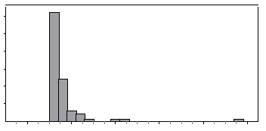 | B4  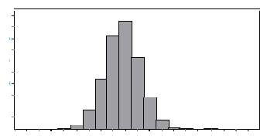
B5  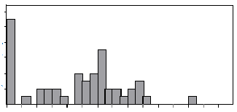 | B6  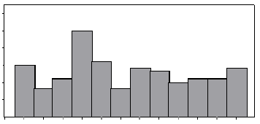
B7  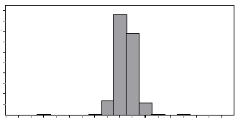 | B8  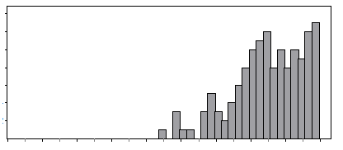

Identifying Distributions – Boxplots
C1  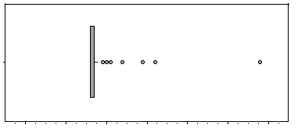 | C2  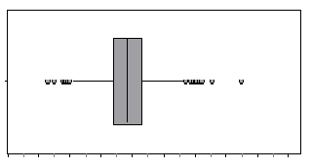
C3  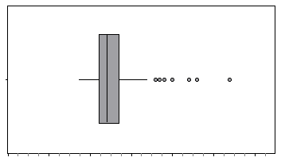 | C4  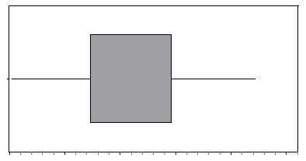
C5  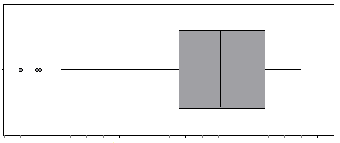 | C6  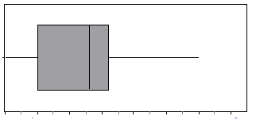
C7  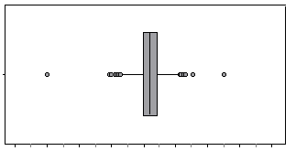 | C8  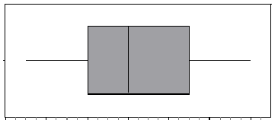

Identifying Distributions - Statistics tables
D1  Minimum 26  Quartile 1 68  Median 77  Quartile 3 86  Maximum 149  Mean 77.2  Standard Deviation 14.3 | D2  Minimum 16  Quartile 1 16  Median 16  Quartile 3 17  Maximum 58  Mean 17.5  Standard Deviation 4.8
D3  Minimum 31  Quartile 1 1460  Median 1460  Quartile 3 2921  Maximum 4452  Mean 1866  Standard Deviation 915  Statistics rounded to the nearest integer. | D4  Minimum 17  Quartile 1 22  Median 24  Quartile 3 27  Maximum 54  Mean 26  Standard Deviation 7  Statistics rounded to the nearest integer.
D5  Minimum 90  Quartile 1 138  Median 151  Quartile 3 164  Maximum 175  Mean 149  Standard Deviation 20  Statistics rounded to the nearest integer. | D6  Minimum 7.201  Quartile 1 7.498  Median 7.520  Quartile 3 7.545  Maximum 7.752  Mean 7.521  Standard Deviation 0.034
D7  One of the variables of interest is ordinal: the values of the variable are actually categories that have order as opposed to having actual numeric values. For this one ordinal variable, no statistics table has been provided. | D8  Minimum 1.28  Quartile 1 100.32  Median 261.99  Quartile 3 321.01  Maximum 600.79  Mean 228.55  Standard Deviation 155.30

Teacher Notes
Common Core Standards addressed by this activity:
Content Standards
  Additional Focus | S | ID.2 | Summarize, represent, and interpret data on a single count or measurement variable. Use statistics appropriate to the shape of the data distribution to compare center (median, mean) and spread (interquartile range, standard deviation) of two or more different data sets.*
  Additional Focus | S | ID.3 | Summarize, represent, and interpret data on a single count or measurement variable. Interpret differences in shape, center, and spread in the context of the data sets, accounting for possible effects of extreme data points (outliers).*
Primary Math Practices
MP 2 Reason abstractly and quantitatively.
MP 3 Construct viable arguments and critique the reasoning of others.
MP 4 Model with mathematics.
MP 6 Attend to precision.

Acknowledgements
Identifying Distributions is adapted from exercises found in Activity-Based Statistics by Schaeffer, Watkins, Gnanadesikan, Witmer and an exercise found in Workshop Statistics: Discovery With Data and the Graphing Calculator by Rossman, Chance, Von Oehsen.
Rossmann, A. J., Chance, B. L., & Von Oehsen, J.B. (2002). Workshop Statistics Discovery with Data and the Graphing Calculator (2nd ed.). New York, NY: Key College Publishing.
Scheaffer, R. L., Gnanadesikan, M., Watkins, A., & Witmer, J.A. (1996). Activity-Based Statistics. New York, NY: Springer-Verlag.

Guidance for Class Activity
Students should work in groups to match the verbal descriptions to their histograms, boxplots and statistics. The cards are arranged so that cards 1 – 4 may be done separately from cards 5 – 8. Teachers may choose to give all 8 situations to their students at one time, or may choose to give situations 1 – 4 as in class work and situations 5 – 8 as homework.
Students should discuss with their groups their reasoning for matching verbal descriptions to a histogram, boxplot and statistics. Once the cards have been matched, a poster should be created displaying the pairings. Students can then be asked to do a “walk around” critiquing the work of other groups by writing comments on post-it notes. Upon returning to their own poster, students should review the posted comments and determine if change is needed. The teacher wraps up the activity with a guided discussion about the reasoning used to determine the matches.

Answer Key

A  Verbal Description | B  Histogram | C  Boxplot | D  Statistics
A1 Winning scores in NCAA Basketball Tournament | B4 | C2 | D1
A2 Age when Bachelor’s Degree was Awarded | B1 | C3 | D4
A3 Days in Office | B2 | C4 | D3
A4 Illinois Driver’s License | B3 | C1 | D2
A5 Weights of Euro Coins | B7 | C7 | D6
A6 Gross Box Office Receipts | B5 | C6 | D8
A7 Month of Birth of Best Actor/Actress | B6 | C8 | D7
A8 The Number of Passengers on a Southwest Flight | B8 | C5 | D5
Note: Southwest Airlines Boeing 737-800 has 175 passenger seats.

